Root Cause Analysis KR-INC-2026-003
T-07 gearbox – ISS bearing failure
David Chen · 29 September 2026 · KR-INC-2026-003-RCA

1. Summary
On 14 January 2026 the rotor-side bearing of the intermediate-speed shaft (ISS) in the T-07 gearbox failed. The teardown at Weserkraft Getriebe GmbH in Bremen (26 February 2026, witnessed by Ben Okoye and Craig Ferguson) found axial cracks with white etching cracks (WEC) in the inner ring, followed by spalling across about 40 % of the raceway. The failure is a known damage mechanism in wind turbine gearboxes. It is associated with transient loads, slip of rolling elements and lubricant chemistry, and it typically shows up long before the bearing's calculated L10 life.
Root cause: WEC-initiated rolling contact fatigue in the ISS bearing inner ring. Contributing factors: (a) a high number of emergency stops and grid-loss events on T-07 in winter 2024/25, (b) CMS alarm thresholds set at generic OEM values that did not trigger, (c) a 'watch' oil result in November 2025 that was not escalated.

2. Evidence
Evidence | Finding
SCADA 10-minute data | Temperature rise from 71 °C to 97 °C within 62 minutes before the trip; no prior temperature alarms
CMS (vibration) | Kurtosis of ISS envelope rising from 3.1 (mid-Nov) to 4.3 (13 Jan); alarm threshold was 4.5
Oil analysis | Fe 14 ppm (May 2025) → 38 ppm (Nov 2025, 'watch') → 212 ppm (post-failure)
Event log | T-07: 31 emergency stops in 2025 (fleet average 17), of which 12 grid-loss related
Teardown report | WEC networks in subsurface at 0.2–0.6 mm depth, axial cracks, no lubrication starvation, no assembly defects
Material analysis | Bearing steel within specification; hardness 60–61 HRC; no inclusions above limit

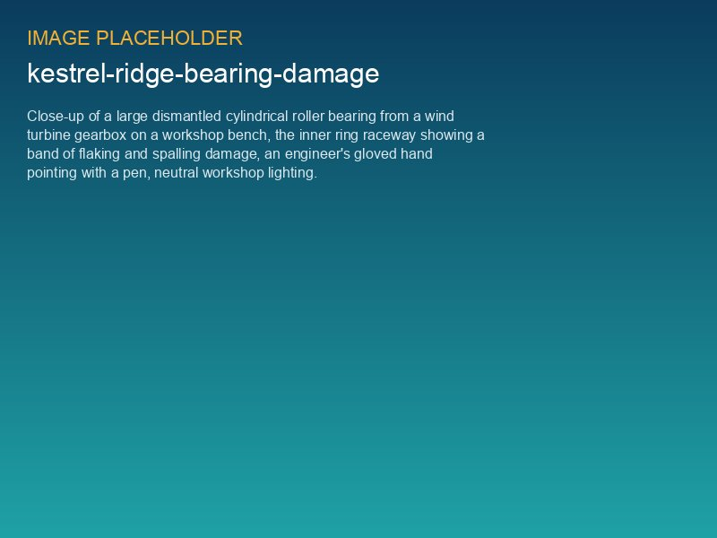
ISS bearing inner ring with spalling and axial cracks

3. Five whys
Why? | Answer
Why did T-07 stop? | Trip on high ISS bearing temperature.
Why did the temperature rise? | The inner ring raceway was spalled, causing friction and debris in the bearing.
Why was the raceway spalled? | Axial cracks from white etching areas grew to the surface (WEC).
Why did WEC develop? | Combination of transient loads (emergency stops, grid loss) and roller slip under low load; known susceptibility of the bearing type.
Why was it not detected earlier? | CMS thresholds too high for this failure mode and no escalation rule for 'watch' oil results.

4. Corrective and preventive actions
# | Action | Owner | Due | Status (Oct 2026)
1 | Fleet endoscope inspection of all ISS/HSS bearings | Highline / Ben Okoye | 2026-03-31 | Done – T-12 finding
2 | Retune CMS alarm thresholds for ISS bearings (kurtosis 4.5 → 3.8, new envelope band) | Sara Lindgren | 2026-04-30 | Done
3 | Reduce gearbox oil sampling interval from 6 to 3 months | Ben Okoye | 2026-03-01 | Done
4 | Escalation rule: any 'watch' oil result → endoscope within 4 weeks | David Chen | 2026-02-28 | Done
5 | Request manufacturer statement on serial defect risk (WEC) | David Chen | 2026-06-30 | Done – no serial defect declared
6 | Evaluate grid-loss emergency stop count per turbine as a load indicator | Sara Lindgren | 2026-09-30 | Done – see Operations
7 | Share lessons learned with fleet (Asset Operations) and Harrow Bay O&M readiness | David Chen | 2026-05-31 | Done
8 | Additive-treated oil trial on 3 turbines (T-04, T-09, T-12) | Ben Okoye | 2026-12-31 | In progress

5. Effectiveness
The retuned CMS thresholds and the endoscope campaign detected early indications on T-12 in March 2026. The T-12 bearing was replaced up-tower in May 2026 at an estimated cost of GBP 85,000 (borne by Highline) instead of a full gearbox exchange with a 750 t crane. The removed T-12 bearing showed the same WEC pattern, which confirms that the detection approach works.
The manufacturer confirmed on 18 June 2026 that two failures in 18 units do not meet the serial defect definition of the contract (≥ 20 %). We will reassess if a third ISS bearing shows WEC indications before March 2029.

